**Project Initialization and Planning Phase**

| Date | 20 august 2025 |
| --- | --- |
| Team ID | Sneha S |
| Project Name | Mushroom |
| Maximum Marks | 3 Marks |

**Define Problem Statements (Customer Problem Statement Template):**

I am a researcher (customer).  
I’m trying to classify mushrooms as edible or poisonous from images.  
But it is difficult to manually identify mushrooms because many look similar.  
Because of this, mushroom foragers and food researchers risk health and safety.  
Which makes me feel unsafe and unsure about wild mushroom consumption.

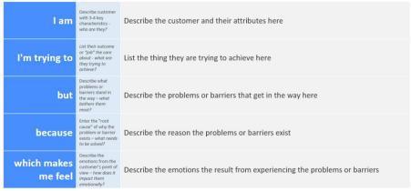

Reference: https://miro.com/templates/customer-problem-statement/

**Example:**

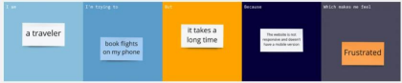

|  |  |  |  |  |  |
| --- | --- | --- | --- | --- | --- |
| **Problem**  **Statement (PS)** | **I am**  **(Customer)** | **I’m trying to** | **But** | **Because** | **Which makes me feel** |
| PS-1 | I am a researcher (customer). | I’m trying to classify mushrooms as edible or poisonous from images | But it is difficult to manually identify mushrooms because many look similar. | Because of this, mushroom foragers and food researchers risk health and safety. | Which makes me feel unsafe and unsure about wild mushroom consumption. |
|  |  |  |  |  |  |